BansilalRamnathAgarwal Charitable Trust’s

Vishwakarma Institute of Information Technology

*(Department of Electronics & Telecommunication)*

**

*A Project entitled*

*“Sound Navigation and Ranging (SONAR) Using Ultrasonic Sensor****”***

*Submitted by*

*Sainathan Ganesh Iyer (17U433)*

*Pratik Prasad Patki(17U456)*

*Prajwal Chandrakant Kamble(17U190)*

Mini Project

T.Y. Electronics &Tele-Communication

*of*

*University of Pune*

*Under the supervision of*

**(Prof. Piyush Mathurkar)**

*Year 2019 – 2020*

BansilalRamnathAgarwal Charitable Trust’s

Vishwakarma Institute of Information Technology

*(Department of Electronics & Telecommunication)*

**CERTIFICATE**

This is to certify that the project “**Sound Navigation and Ranging (SONAR) Using Ultrasonic Sensor”** has been successfully completed by

|  |  |  |
| --- | --- | --- |
|  |  | Sainathan Ganesh Iyer |
|  |  | Pratik Prasad Patki |
|  |  | Prajwal Chandrakant Kamble |

It is a work done by the students and has not been submitted previously by any other student/students.

The work is done, on the basis of the work allotted to these students, based on various Project ideas presented by them.

This project report is being submitted as a part of the subject Mini Project at T.Y.-E&TC

(Prof. Piyush Mathurkar) (Dr. Shailesh Kulkarni)

Project Guide H.O.D- E& TC

### ACKNOWLEDGEMENT

We owe deep gratitude to our project guide Prof. Piyush Mathurkar who took keen interest on our project work and guided us all along, till the completion of our project work by providing all the necessary information for developing a good system.

Sainathan Ganesh Iyer

Pratik Prasad Patki

Prajwal Chandrakant Kamble

**INDEX**

|  |  |  |
| --- | --- | --- |
| **Sr.No** | **Content** | **PageNo.** |
| 1. | INTRODUCTION……………………….............................. | 1 |
| 2. | BACKGROUND………...………………………………….. |  |
| 3. | BLOCK DIAGRAM………………………………………… |  |
| 4. | ELECTRONIC AND HARDWARE DESIGN ASPECTS… |  |
| 5. | SOFTWARE ASPECTS……………………………………. |  |
| 6. | CIRCUIT DESIGN…………………………………………. |  |
| 7. | SIMULATION RESULTS………………………………….. |  |
| 8. | TESTING OF MODULES………………………………….. |  |
| 9. | CABINET DESIGN AND ASSEMBLY…………………… |  |
| 10. | BILL OF MATERIALS…………………………………….. |  |
| 11. | REFERENCES……………………………………………... |  |
| 12. | PROJECT PHOTO………………………………………….. |  |
| 13. | CONCLUSION …………………………………………… |  |
| 14. | DATA SHEETS…………………………………………….. | 20 |

**INTRODUCTION**

Sound Navigation and Ranging (SONAR) is a Remote Sensing System with important military, scientific and commercial applications. Active SONAR transmits acoustic (i.e., sound) waves. These waves return echoes from certain features or targets that allow the determination of important properties and attributes of the target (i.e., shape, size, speed, distance, etc.). Because electromagnetic waves are strongly attenuated (diminished) in water, RADAR signals are mostly used for ground or atmospheric observations. Because SONAR signals easily penetrate water, they are ideal for navigation and measurement under water.

Modern [naval warfare](https://en.wikipedia.org/wiki/Naval_warfare) makes extensive use of both passive and active sonar from water-borne vessels, aircraft and fixed installations. Although active sonar was used by surface craft in [World War II](https://en.wikipedia.org/wiki/World_War_II), submarines avoided the use of active sonar due to the potential for revealing their presence and position to enemy forces. However, the advent of modern signal-processing enabled the use of passive sonar as a primary means for search and detection operations. In 1987 a division of Japanese company [Toshiba](https://en.wikipedia.org/wiki/Toshiba) reportedly sold machinery to the [Soviet Union](https://en.wikipedia.org/wiki/Soviet_Union) that allowed their submarine propeller blades to be milled so that they became radically quieter, making the newer generation of submarines more difficult to detect.

The use of active sonar by a submarine to determine bearing is extremely rare and will not necessarily give high quality bearing or range information to the submarines fire control team. However, use of active sonar on surface ships is very common and is used by submarines when the tactical situation dictates it is more important to determine the position of a hostile submarine than conceal their own position. With surface ships, it might be assumed that the threat is already tracking the ship with satellite data as any vessel around the emitting sonar will detect the emission. Having heard the signal, it is easy to identify the sonar equipment used (usually with its frequency) and its position (with the sound wave's energy). Active sonar is similar to radar in that, while it allows detection of targets at a certain range, it also enables the emitter to be detected at a far greater range, which is undesirable

|  |  |  |
| --- | --- | --- |
|  |  |  |

**BACKGROUND**

Although some animals (dolphins, bats, some shrews, and others) have used sound for communication and object detection for millions of years, use by humans in the water is initially recorded by Leonardo da Vinci in 1490: a tube inserted into the water was said to be used to detect vessels by placing an ear to the tube.

In the late 19th century an underwater bell was used as an ancillary to lighthouses or lightships to provide warning of hazards.

The use of sound to "echo-locate" underwater in the same way as bats use sound for aerial navigation seems to have been prompted by the *Titanic* disaster of 1912. The world's first patent for an underwater echo-ranging device was filed at the British Patent Office by English meteorologist Lewis Fry Richards on a month after the sinking of *Titanic*, and a German physicist Alexander Behm obtained a patent for an echo sounder in 1913.

The Canadian engineer Reginald Fessenden, while working for the Submarine Signal Company in Boston, Massachusetts, built an experimental system beginning in 1912, a system later tested in Boston Harbor, and finally in 1914 from the U.S. Revenue Cutter *Miami* on the Grand Banks off Newfoundland.In that test, Fessenden demonstrated depth sounding, underwater communications (Morse code) and echo ranging (detecting an iceberg at a 2-mile, 3.2 km range). The "Fessenden oscillator", operated at about 500 Hz frequency, was unable to determine the bearing of the iceberg due to the 3-metre wavelength and the small dimension of the transducer's radiating face (less than ​1⁄3 wavelength in diameter). The ten Montreal-built British H-class submarines launched in 1915 were equipped with Fessenden oscillators.

**BLOCK DIAGRAM**

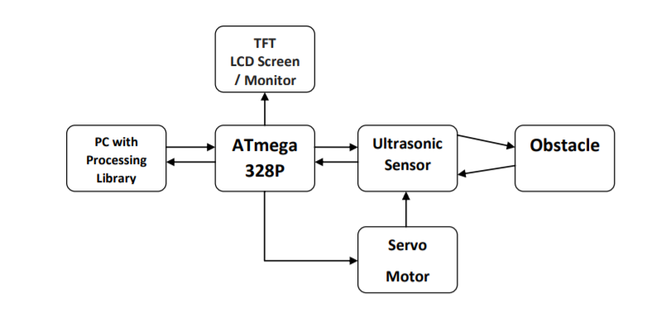

**ELECTRONIC AND HARDWARE DESIGN ASPECTS**

After hours of brainstorming with group and searching online for different ideas across various domains, finally this project was selected.

As the project was to be implemented from scratch, a feasibility report was generated in which we considered factors such as:

* Availability of time
* Duration of mini project
* Availability of resources (H/W, S/W)
* Availability of skill set or time required to learn new skills etc.

**Domain selection**:

Geographical Information System (GIS) and remote sensing

The selected project has immense value addition opportunities I the selected domain and is a perfect blend of hardware and software.

After finalizing domain and the project a Synopsys was prepared giving an overview of the project.

**Selection of Component**:

Although 8051 was our first option, since it was covered in MCA subject and we have sufficient knowledge of assembly language, we decided to select Arduino (Atmega 328p) because 8051 has some drawbacks such as:

* The 8051 input need to be configured correctly, times have to be initialized and code should be written to start and stop the timers.
* When compared to 8051, Atmega has inbuilt ADCs (required for sensor data conversion, serial communication pins and high clock rate).
* Programming Atmega is very easy as compared to 8051.
* A better IDE is provided with arduino.
* Availability of readymade libraries in arduino for serial interfacing.
* Processing library is compatible with arduino.

Looking at all the above points, microcontroller finalized was Arduino Uno R3.

**SOFTWARE ASPECTS**

Processing is a flexible software sketchbook and a language to code within the contact of the visual arts. It’s free to download and open source.

Libraries are used to extent “Processing” beyond graphics and images into audio, video and communication with other devices.

Serial – Send data between processing and external hardware through serial communication.

Produce for adding library select “Add library” 🡪 “Import library” from submenu.

When we send data to the console, the console is relatively slower. For real time monitoring of serial value, we rendered those values to the processing window using draw ( )

**Important import for the processing code:**

import processing.serial.*; // import library for serial communication

import java.awt.event.keyEvent; // import library for reading data from the serial port

import java.io.IoException; // for handling exception

**CIRCUIT DESIGN**

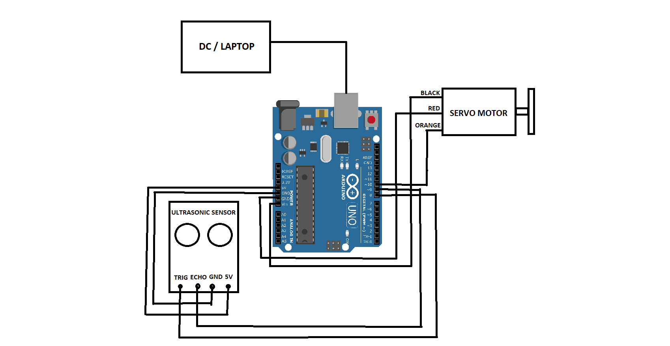

**TESTING OF MODULES**

**Prototype 1 :**

|  |  |  |  |
| --- | --- | --- | --- |
| **Sr. No.** | **Actual Distance**  **(cm)** | **Measure Distance**  **(cm)** | **Error**  **(cm)** |
| 1 | 10 | 9.3 | 0.7 |
| 2 | 20 | 18 | 2 |
| 3 | 30 | 31.6 | 1.6 |
| 4 | 35 | 34.7 | 0.3 |
| 5 | 40 | 42 | 2 |

Average Error **=**(0.7+2+1.6+0.3+2) / 5 = 1.32 cm

**Prototype 2 :**

|  |  |  |  |
| --- | --- | --- | --- |
| **Sr. No.** | **Actual Distance**  **(cm)** | **Measure Distance**  **(cm)** | **Error**  **(cm)** |
| 1 | 10 | 9.8 | 0.2 |
| 2 | 20 | 21.5 | 1.5 |
| 3 | 30 | 30.7 | 0.7 |
| 4 | 35 | 34.8 | 0.2 |
| 5 | 40 | 39.8 | 0.2 |

Average Error **=**(0.2+1.5+0.7+0.2+0.2) / 5 = 0.56 cm

**Prototype 3 :**

|  |  |  |  |
| --- | --- | --- | --- |
| **Sr. No.** | **Actual Distance**  **(cm)** | **Measure Distance**  **(cm)** | **Error**  **(cm)** |
| 1 | 10 | 9.8 | 0.2 |
| 2 | 20 | 19.6 | 0.4 |
| 3 | 30 | 31.1 | 1.1 |
| 4 | 35 | 35 | 0 |
| 5 | 40 | 40.1 | 0.1 |

Average Error **=**(0.2+0.4+1.1+0+0.1) / 5 = 0.36 cm

**CABINET DESIGN AND ASSEMBLY**

**BILL OF MATERIALS**

|  |  |
| --- | --- |
| **Components** | **Price (INR)** |
| Arduino Uno R3 | 360 |
| Servo motor SG90 | 150 |
| Ultrasonic sensor HCSR-04 | 90 |
| Jumper wire | 60 |
| Acrylic sheet | 100 |
| Fevikwik | 40 |
| Total | 800 |

**REFERENCES**

1. **Processing Software:-**

https://processing.org/download/

1. **Processing Libraries for Hardware I/O:-**

<https://processing.org/reference/libraries/io/index.html>

1. **Arduino Software:-**

<https://www.arduino.cc/en/main/software>

1. **NewPing Library for Arduino:-**

<https://playground.arduino.cc/Code/NewPing/>

1. **Research Paper: “Localization System for Autonomous Mobile Platform” by** [**P. Ramos**](https://ieeexplore.ieee.org/author/37574887900)**;**[**F. Lobo Pereira**](https://ieeexplore.ieee.org/author/37290921600)

<https://ieeexplore.ieee.org/document/648643/>

1. **All about ultrasonic sensors and their working:-**

<https://www.arrow.com/en/research-and-events/articles/ultrasonic-sensors-how-they-work-and-how-to-use-them-with-arduino>

**PROJECT PHOTO**

Prototype 1:- Line Structure

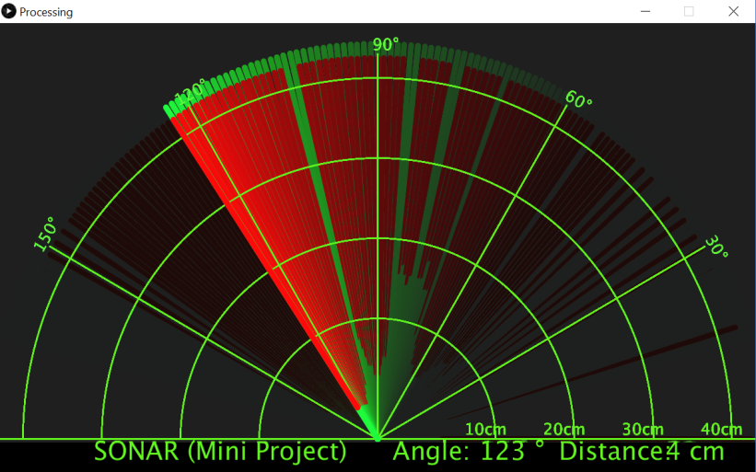

Prototype 2:- Live Tracking Structure

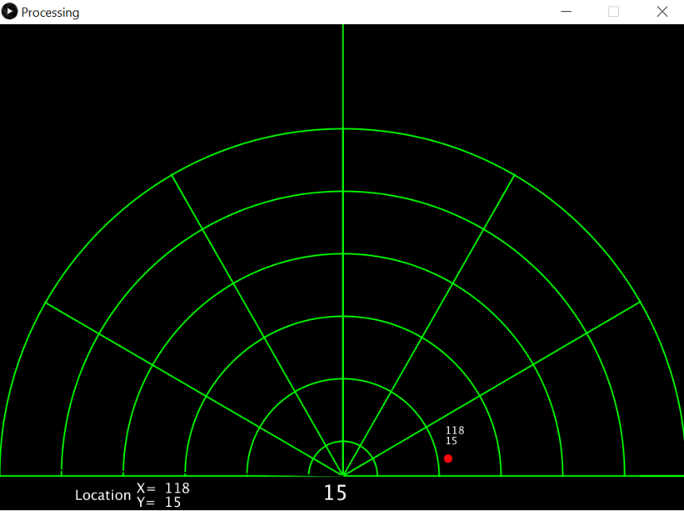

Prototype 3:- Dot Structure

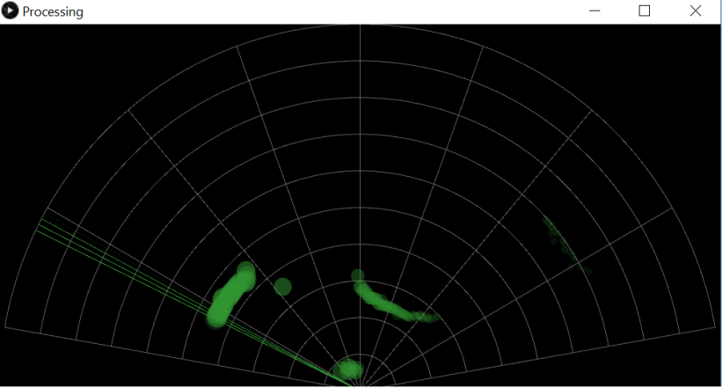

**CONCLUSION**

The SONAR project is more of a visual project than it is a circuit implementation. We have used different hardware like Arduino UNO R3, HC-SR04 Ultrasonic Sensor and a Servo Motor but the main aspect is the visual representation in the Processing Application. Performance has been improved across different prototypes. In the First Prototype (Line Structure) proper size of the object was not estimated because it plotted extending lines across the complete boundary of the object. In the Prototype 2 Live Tracking of the “In Range Moving Object” was possible. And finally in Prototype 3 (Dot Structure) the moving objects as well as stable objects and their past locations can be visualized graphically.